Topic. Health activism, citizen accountability and UHC in Kenya
Caption: From 2018-2020, Kenya piloted a World Bank model of UHC, with an intent to scale up to national implementation. PHM Kenya mobilized to engage citizens and local health authorities and present an alternative view of the UHC model.
- Background
Access to quality and affordable healthcare is a fundamental human right. Article 43(1)(a) of the Constitution of Kenya provides that every person has the right to the highest attainable standard of health, which includes the right to health care services, including reproductive health care.
The constitution further devolved provision of health care services to the county governments. The World Health Organization (WHO) has been encouraging its member states (Kenya included) to develop and implement a Universal Health Coverage (UHC) system that ensures that quality preventive, curative, promotive and rehabilitative healthcare services are accessible to all without facing the risk of financial constraints. Additionally, the Council of Governors appreciates that Universal Health Coverage (UHC) is a vital aspect in ensuring that citizens get their desired health as highlighted in the Kenya Health Policy.
In light of this, Kenya launched the pilot phase of its UHC program on 12 December 2018 as part of its effort to achieve Sustainable Development Goals 3 and Vision 2030. The UHC pilot was launched in four counties, namely: Kisumu, Machakos, Nyeri and Isiolo. Apart from domestic political considerations and balancing sub-national ethnic interests, the counties were selected due to their varied health challenges: Kisumu is a county with high incidence of communicable diseases, Machakos has a high incidence of road traffic accidents: and Nyeri has non-communicable diseases and Isiolo has migrant populations. The main goal of the UHC programme was to facilitate access to quality and affordable health care, with a commitment to achieving UHC by 2022. Without other structural reforms in the health sector, any ongoing monitoring, evaluation or social accountability mechanisms, or even clarity on the UHC defined benefit package, the Kenyan Ministry of Health and the four counties operated the pilot UHC model until April 2020. Ultimately, Kenya’s UHC pilot failed, with acknowledgement from county and national leadership that the subscription model did not work, for reasons captioned below.
- Expanded existing public insurer (NHIF) without explicit benefits package or other health systems reforms;
- No monitoring, evaluation or social accountability for the UHC pilot or programme;
- Pilot UHC subscription fees were subsidized by the World Bank, but the national scale-up would have required household out-of-pocket payments.
A revision to the UHC model is slated for launch in 2021.
Situation context
According to the government’s Budget Policy Statement (BPS), 2018, the key deliverables of the UHC, were to reduce 50 percent out-of-pocket medical expenses incurred by Kenyans, as well as cover over 1.5 million poor households.¹ However, the pilot project faced a number of challenges, prominently including (a) non-involvement and exclusion of communities, (b) human rights violations, (c) inadequate information, transparency and resource allocation, (d) lack of planning and documentation of what the pilot and national UHC actually meant, (e) corruption and (f) lack of strategic direction on its implementation. The reports from the KEMRI UHC Population Needs Baseline Survey Findings, of April 2019 acknowledged the weaknesses of the roll out phase citing the program was rushed, non-consultative and lacked inclusion of the end user as a key stakeholder.
In light of the above, The People’s Health Movement-Kenya (PHM-Kenya), a civil society network which tracks, defends and promotes the realization of the constitutional right to health for all, commissioned a nationwide perception study on UHC in September 2019. The study captured public views and perception on affordability, accessibility and quality of UHC and government health care services, provision and payment of health services, household expenditure on health care, distance from the nearest health facility and penetration of medical cover .The survey applied in-person (pre-Covid) and telephone interviews with respondents from the four pilot counties and a representative sample of 1200 respondents from another 24 counties. The results enumerated a number of key government issues which needed addressing before the roll out of the UHC program country-wide.
Citizens’ perceptions and experiences with the UHC pilot
Healthcare service delivery (at 19%) was ranked among the top ten key concerns of Kenyans. Up to 40% of Kenyans rated provision of healthcare services by both national and county governments as poor; only 28% rated it as good. The responsibility to provide and pay for healthcare services was perceived by a majority of Kenyans as that of the County government at 61% and 53% respectively. A majority (51%) of Kenyans indicated that they do not have any form of medical insurance. Of those who had insurance, 89% reported that they relied on the public National Hospital Insurance Fund (NHIF), available to salaried employees. Figure 1, below, summarizes the primary expectations of UHC among the 2200 nationally sampled respondents.
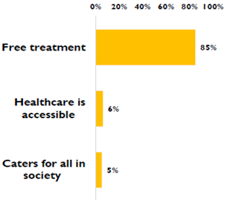
Figure 1: People’s expectations of UHC in Kenya (2019)
On access, slightly above half (57%) of Kenyans indicated that they had not visited a public health facility in the past year mainly because of poor health care services in the facilities. A majority of Kenyans (69%) were not even aware of UHC. However, after explaining the concept of UHC to respondents, around 8 in every 10 (82%) rated the UHC program as important.
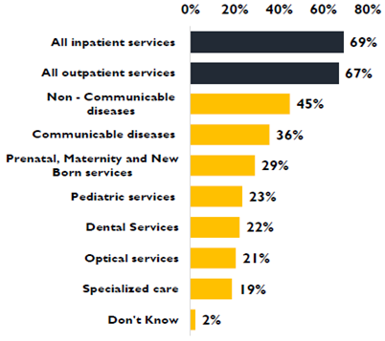
Figure 2: Public demands for services under UHC in Kenya (2019)

The study revealed that 42% of the citizenry in the four UHC pilot counties had registered for the programme, with a majority of those who registered coming from older age cohorts.
Other key findings are listed below.
- 85% perceived UHC as no cost to households, and a majority (69%) were unaware of future UHC charges;
- Public demands of medical services included inpatient services (69%), outpatient services (67%), NCD treatments (45%) and communicable disease care (36%) - see Figure 2 above;
- Interviews highlighted quality gaps in UHC services as follows (see also Figure 3, below)
  - drug stock-outs,
  - long facility waiting times,
  - health worker shortages,
  - inconsistent and low quality service delivery across public hospitals, and
  - corruption/demands for informal payments prior to service delivery.
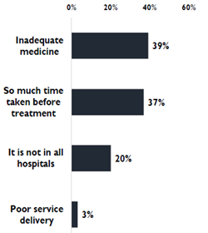
Figure 3: Reported experiences with UHC pilot in Kenya (2019)
Analysis of Kenya’s health policies and implementation showed that the MOH did not communicate its intention to require UHC household subscription fees; and further that the World Bank subsidy for the UHC pilot distracted policy-makers from long-term planning and deceived Kenyan households about actual costs. Further, low budgetary allocations from the national MOH for primary health care and prevention were inadequate, and imposed additional burden on UHC to cover costs for preventable conditions.
All in all, a majority of people favored UHC because it was presented as free during the pilot but were unaware that the national UHC programme would require monthly household subscription payments. Further, respondents did not like health system gaps that continued with UHC, such as inadequate supply of drugs and medical commodities, long wait times and lack of sufficient numbers of skilled health workers.
A summary of the key points from the Kenya UHC perception survey:
- Expectations of comprehensive health care at no cost, versus reality of UHC as only financing without health system reforms
- UHC requires broader health system changes, beyond financing

Workshops and Town hall meetings to disseminate findings
PHM Kenya convened a town hall meetings with stakeholders in six counties (Mombasa, Isiolo, Nyeri, Machakos, Kisumu and Makueni), to disseminate the findings of the UHC perception survey among lay residents and government officers, including the County Executive Commissioners for Health. Further, the meetings sought to devise a way forward on achieving a transparent, accountable and people-centered UHC in Kenya, with government and CSO representatives together in the discussions.
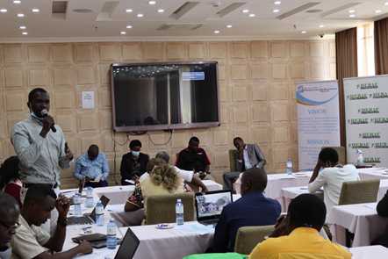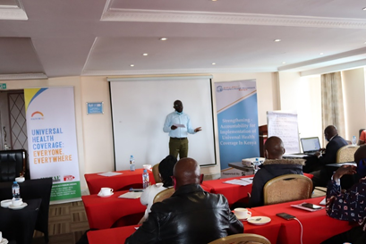Participants sharing session on UHC in Nyeri and Machakos counties
The objectives of the workshops and town-hall discussions were to achieve the following:
- To disseminate the findings from the survey on citizen’s perspectives with UHC, share experiences from patients and other users on the challenges they faced in the health sector in counties and what they might expect from a national UHC rollout,
- To hear from duty bearers on how they plan to implement the national roll out of UHC, and
- To come up with an action plan to jointly advocate for a rights-based, transparent and accountable national UHC programme.
PHM-Kenya was actively involved in writing statements, sharing news and ideas on social platforms and mainstream media, and critiquing the market model of UHC that the national government had been pursuing in the pilot phase.
Next steps
Across the government, country leaders, PHM Kenya and other civil society groups, there is a need to continuously engage with the people at the county level in a more proactive way to bring onboard the particular stakeholders to get the feedback needed. For sustainability, PHM Kenya aims to strengthen local people’s capacity to continue with the work. For example, PHM Kenya may develop a manual to be used for capacity building for the people to know about UHC, and their rights and responsibility. Strengthening of already formed networks is another means by which PHM Kenya will continue to challenge any profit-centered model of UHC.

https://docs.google.com/document/d/0B_7ZxcCoDPTtd3hJTzZWeUdqMGhzS1c2Q0htRDJ3OVFEZ0NV/edit?rtpof=true
https://www.youtube.com/results?search_query=Health+activist+condemn+cs+kagwe

