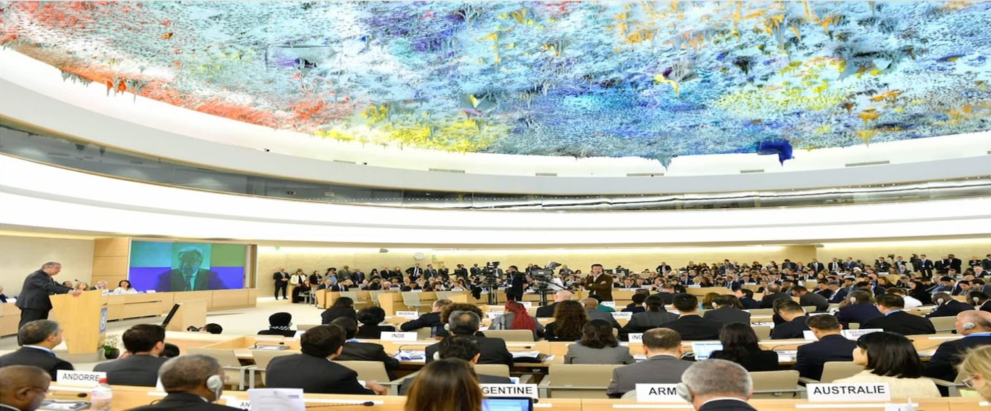
WHA77 WATCH
Statement
This WHA77 Watch statement was delivered in cooperation with Medicus Mundi International – Network Health for All

Agenda item 29
Matters for information: progress reports (Items A-O)

We appreciate WHO’s commitment to integrating gender analysis and a gender-responsive approach into its work. However, the progress report on resolution WHA 60.25 lacks sufficient information to advance this goal. WHO must incorporate gender perspectives into policy development, planning, execution, oversight, and assessment to fulfill its global agendas.
The COVID-19 pandemic highlighted deficiencies in integrating and recognising gender as a cross-cutting issue. Collecting and using gender-disaggregated data to develop gender-responsive policies is fundamental and must be promoted to advance goals of gender justice and health equity.
We commend the Secretariat’s adoption of a survivor-centered approach to addressing sexual violence and emphasis on total transparency in reporting cases and disciplinary actions. We urge WHO to devote more attention and resources to consolidate the progress made and extend this work beyond the current three-year strategy.

--
WHO Watch
Democratising Global Health Governance Programme
People’s Health Movement

